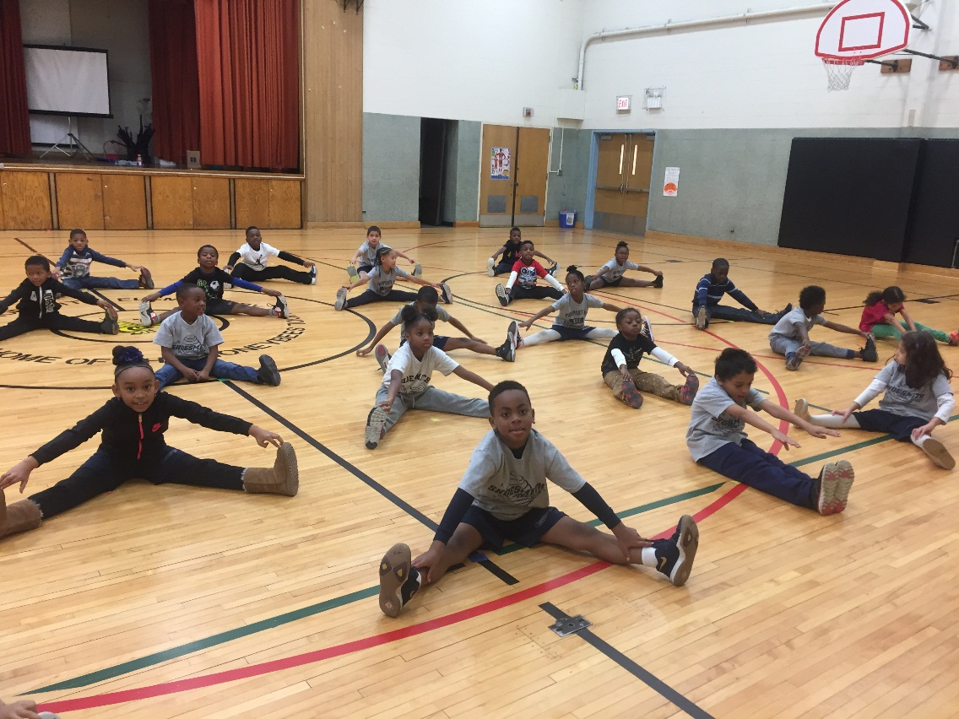 |  | ShoesmithHealthy Buzz  - By: Ms. Schnall  - Issue Date

Can you Stretch with us?

Working out in the winter
You’re not imagining it. Winter still isn’t over. But don’t let the season be an excuse to stray from those resolutions and lose your workout mojo. We’ve rounded up our favorite calorie-busting workouts that can be done indoors to get through these final weeks of winter. And who knows — you might even find a workout you’ll want to do all year long.
1. Ride it out. So the idea of wiping out on black ice or feeling the cold breeze freeze your face while bike riding isn’t appealing? Try a Spin class. These intense indoor cycling classes can burn up to hundreds of calories and keep bones strong.
2. Lap it up. It’s never too early to dig up that swimsuit. Head to your gym or community center’s indoor pool to get in a few solid swims before summer hits.
3. Resistance train. No need to venture outside — a gym isn’t required for these 50 bodyweight exercises, guaranteed to improve strength and endurance. https://greatist.com/fitness/50-bodyweight-exercises-you-can-do-anywhere
4. Hit a wall. An indoor rock climbing wall, that is. This non-traditional cardio workout really hits the mark for those who want to exercise their mental strength.
5. Lace up. Ice skating isn’t just for kids. If it’s too cold for outdoor skating to be fun, head to your local indoor rink to carve up the ice. Aside from being super fun, skating tones the legs, core, and butt, along with smaller, stabilizing muscles that assist with balance and coordination.
6. Just dance. Your Shoesmith student knows a ton of fun dances that they can teach you. Have a dance party in your very own living room.
7. Get your gloves up. Make like Rocky and get to a kick-butt boxing class. A few rounds in the ring provide a full-body workout as you duck, block, and throw punches.

8. Zen out. Give your mind and body a workout with yoga. Check out YouTube for fun Yoga videos every can use.
9. Jump on it. Unleash the kid in you and hop to the nearest trampoline. Just six minutes of cardio moves on a trampoline is the equivalent to running, oh, about a mile.
10. The commercial challenge. Students at Shoesmith are encouraged to use TV as a way to workout. Every time a commercial comes on the whole family can do push-ups, sit ups, run in place, Yoga tree stand, marching in place, running in place and anything other stretching or cardio exercise you can perform. When the commercials are finished, continue to watch your show as usual. During an hour long show, you can expect to rack up 15 minutes of activity.
Every day, it is recommended to have at least 60 minutes of activity for everyone. Using these winter ideas, your whole family will be exercise ready for the spring.
REMINDER: The next Wellness Team meeting will be held March 15th.8:00-8:30 in the Science lab.
Chickpeas and Tomatoes
Makes: 6 Servings
Prep time: 5 minutes
Cook time: 15 minutes
Chickpeas, also known as garbanzo beans, are a popular part of vegetarian meals in Northern Africa. In this recipe, chili powder, cumin, and ginger create a wonderful flavor, without too much heat.

Ingredients
1 teaspoon Canola oil
1 1/4 cups Onion, fresh, peeled, 1/4" diced
2 cloves Garlic, fresh, minced (1 clove is about 1/2 teaspoon minced)
1/2 teaspoon Ginger, fresh, grated (If using ground ginger reduce amount by half)
2 1/2 cups Garbanzo beans (chickpeas), canned, drained, and rinsed or garbanzo beans, dry, cooked
3 cups Tomatoes with juice, canned, low-sodium, diced
1/4 cup Water
1/2 teaspoon Chili powder
1 1/2 teaspoons Cumin, ground

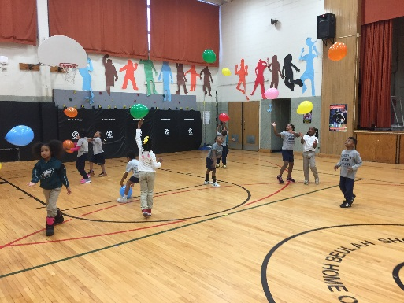

Directions
1. Heat oil in a small stockpot on medium-high heat. Add onions and sauté until soft. Do not brown. Add the garlic and ginger, stir until fragrant.
2. Add the garbanzo beans (chickpeas), tomatoes and juice, water, chili powder, and cumin.
Continue cooking on medium-high heat and bring to a boil.
3. Reduce heat to medium and simmer uncovered for 10 minutes or until there is only enough liquid to cover the bottom of the pan. Heat to 140 °F or higher for at least 15 seconds.
For more fun recipes check: https://www.fns.usda.gov/cacfp-recipes
GYM SHOES! Please make sure your child is dressed for PE with gym clothes and shoes. Students will not be allowed to play in boots. Thank you!

Around Town

Lorem Ipsum

Dolor Sit Amet

Lorem Ipsum

by [Article Author]

Title Lorem Ipsum

ShoesmithHealthy Buzz
By: Ms. Schnall
[Street Address]
[City, ST ZIP Code]

[Addressee]
[Street Address]
[City, ST ZIP Code]

