​​ 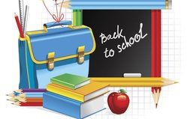
First Grade
School Supply List
2 Bottles of hand sanitizer
2 Large boxes of Kleenex
​2 Paper towel rolls
2 Containers of Lysol disinfecting wipes
1 Container of baby wipes
3 Packs of pencils
2 Boxes of crayons
1 Box of colored pencils
1 Pair of scissors
1 Box of Ziploc bags (small or large)
2 Packs of glue sticks
1 Pair of scissors
1 Pack of dry erase markers
1 Pack of colored construction paper
2 Packs of computer paper
Thank you,
First Grade Team

